MACH4METAL

metalworking machinery
Transito 21, 6909 DA Babberich, Netherlands
Tel. + 31 (0)316 – 247123
Fax. + 31 (0)316 - 247956
info@mach4metal.com
www.mach4metal.com
Bank No : 66.52.13.883
IBAN : NL33 INGB 0665 2138 83
BIC : INGBNL2A
VAT : NL 815393635B01

HEYNUMAT 3 U CNC LATHE

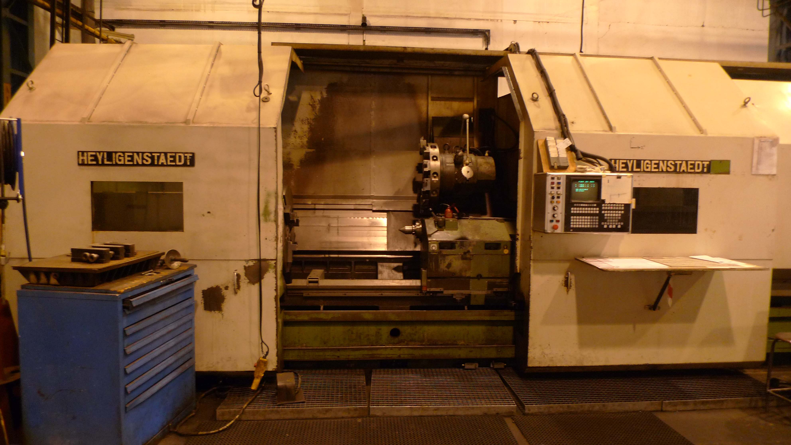
- Make : Heyligenstaedt Germany
- Typ : Heynumsat 3U x 5000
- Age : 76 / 1989
- Mach.No : 1850 61001

- Swing over bed : 930
- Swing over carriage : 675
- DBC turning length : 5.000
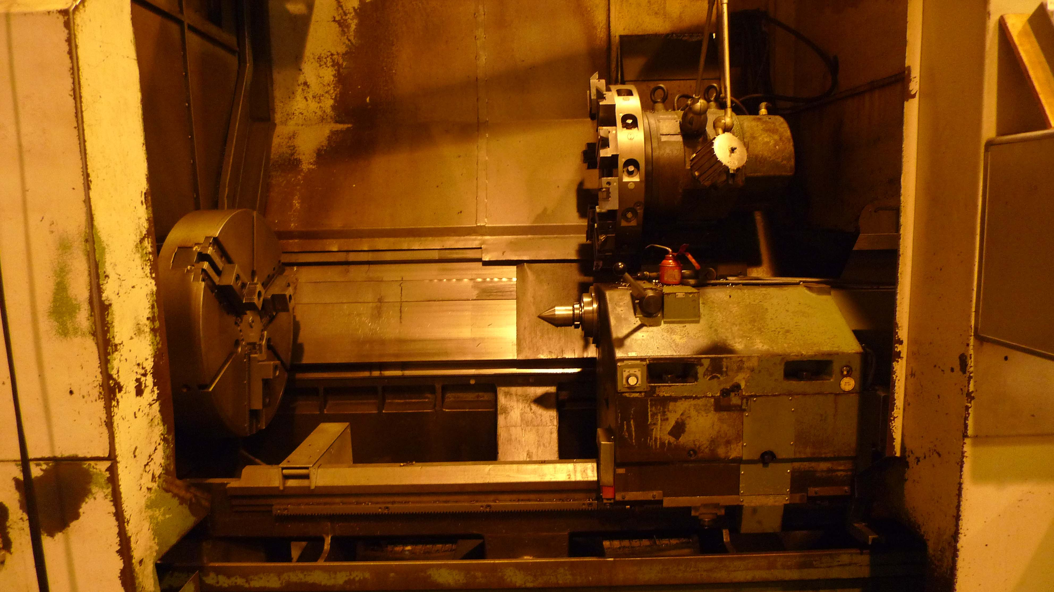
- Carriage stroke : 600

- Spindle bore : 125
- Speeds from to : 7,1 – 1800
- Torq : 12.500 Nm
- Feeds : 10.00 mm/min.

- Diameter tailstock spindle : 125
- Morse taper : Mk-5
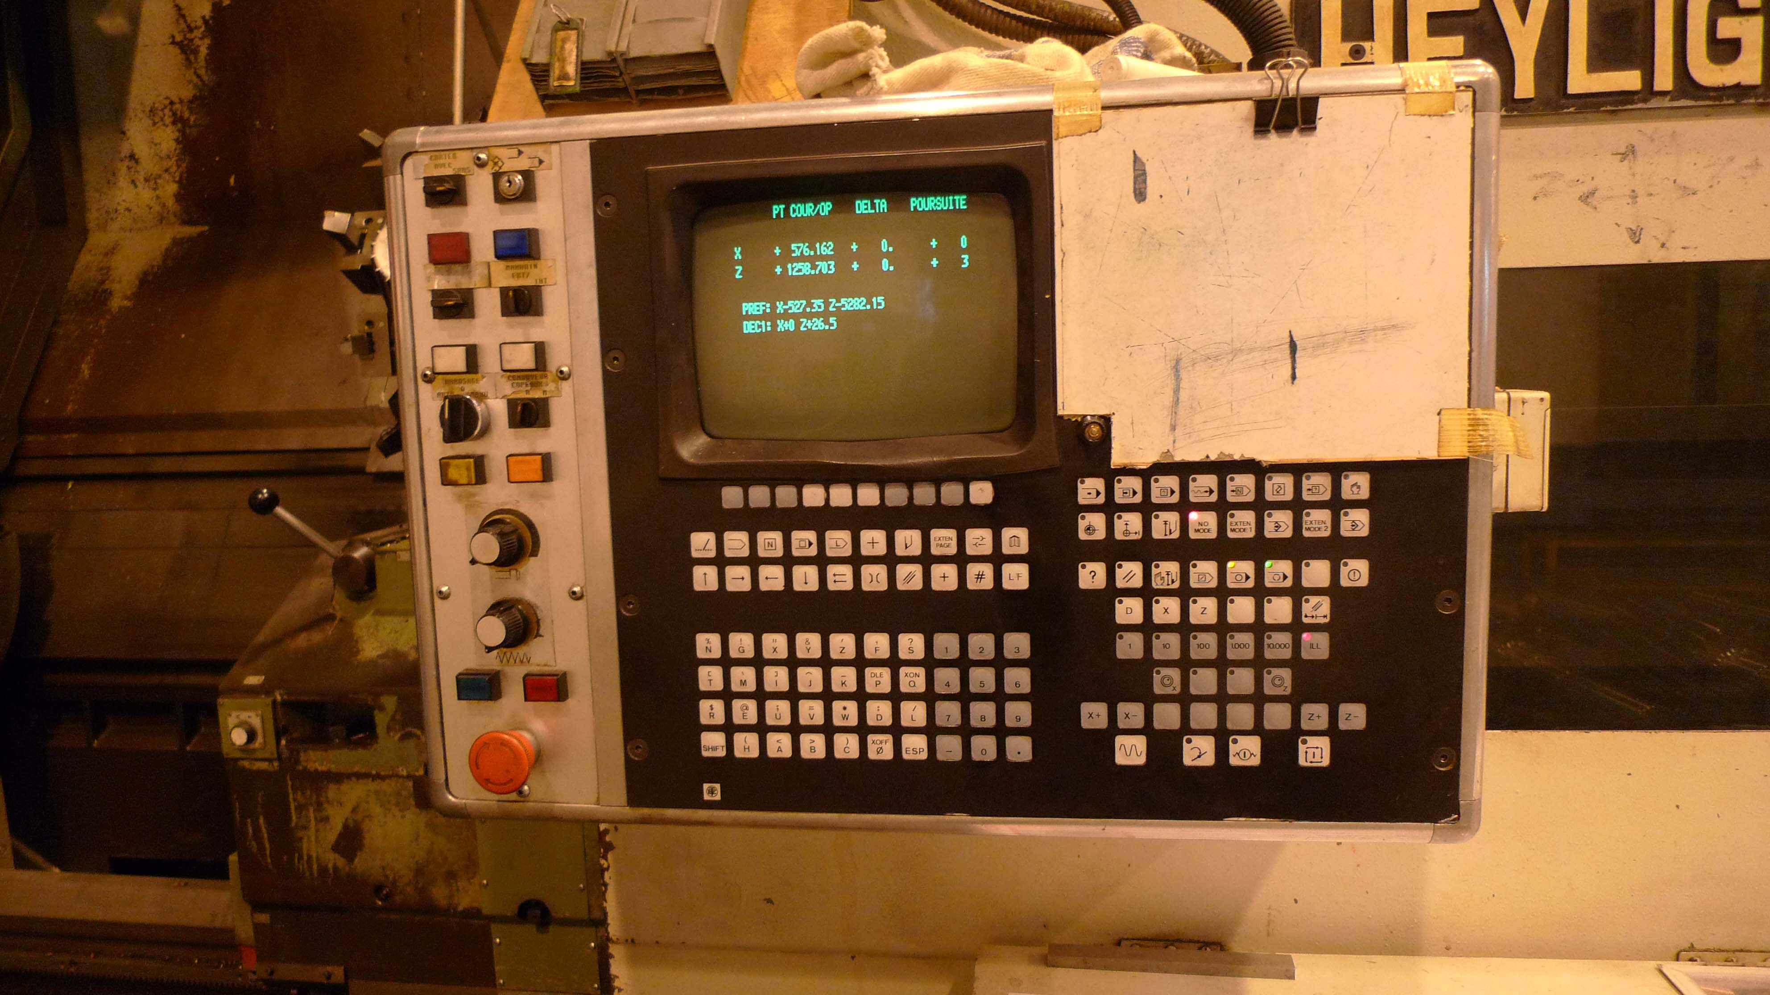

- 12 position tool changer VDi
- Chip conveyor on full length
- Slant bed construction

- Dimensions:
- Weight : 18.500
- Length :
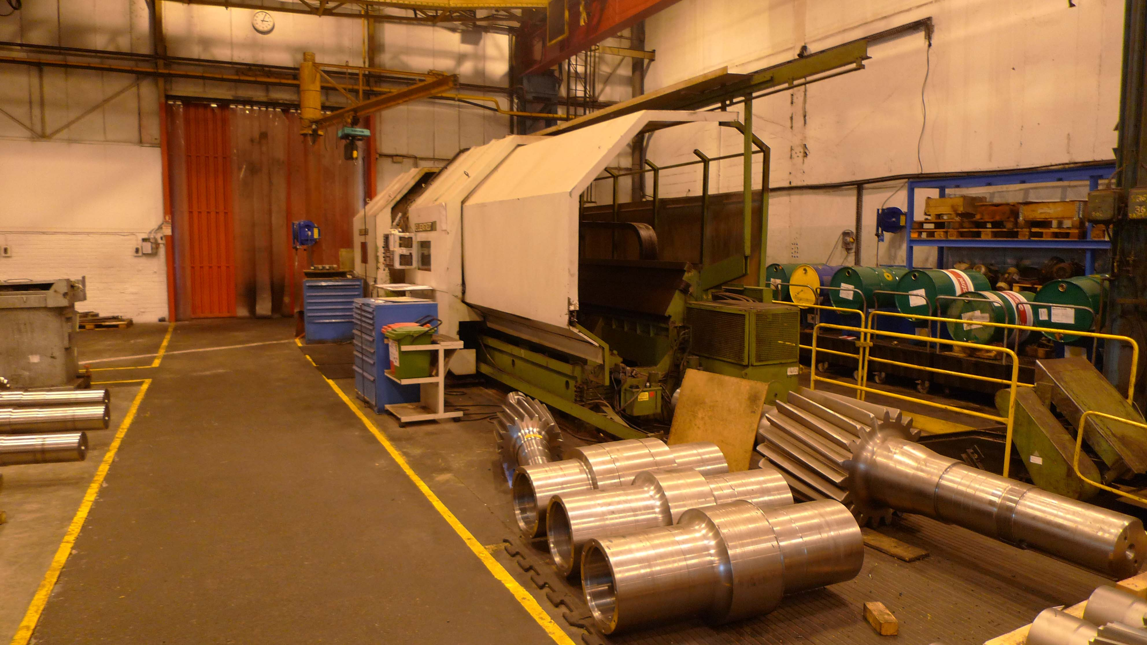
- Width :
- Height :

- Motor power Kw 75 / 400 V :
- CNC Control NUM 1060

- Incl. chucks !
- Incl. tooling / vdi / documantation

Please Note: The above information has been obtained to the best of our ability and belief from, and from the manufacturers where possible. It is given in good faith, but its accuracy can not be guaranteed. Accordingly, it will not form a representation or constitute contractual terms. We advise you to check any vital details!

